FIT5057 Assignment 2B: Project Plan Report Template

COPYRIGHT WARNING
Commonwealth of Australia Copyright Act 1968
Warning
This material has been reproduced and communicated to you by or on behalf of Monash University in accordance with section 113P of the Copyright Act 1968 (the Act).
The material in this communication may be subject to copyright under the Act. Any further reproduction or communication of this material by you may be the subject of copyright protection under the Act.
Do not remove this notice.

Cover Sheet



Tutorial Class ID, Day/Time:
MS Team Group Number:
Student ID | Surname | Other Name/s

Executive Summary
Today, our lives are undergoing tremendous changes due to the global epidemic. The medical society is working hard to develop vaccines to fight the virus, meanwhile, the technology industry also contributes its own strength.
CovidSafe is such an app with great responsibility and power, which is developed by many engineers and project managers. Our Monash Covid Analytics System (MOCAS) project is based on CovidSafe and aim to build a transit database to store patient data in Victoria. This project will improve some of the inconveniences of data transmission and storage in CovidSafe and create a safer environment for the entire process. We believe that the virus will be defeated as soon as possible through the efforts of all parties in the science and technology community.
The main structure of our project contains 5 managements: People / Scope / Schedule / Budget / Risk. We will introduce our people management in section 3.4, which will clearly show our recruitment plan and stakeholder arrangement. The employees who will be properly managed in our project are all professional and reliable to bring you the best project development experience. Following 3.4, section 3.5 will state the scope of both product and project of MOCAS database. As section 3.6 indicates, we will start this project on 11/02/2020 and hope to finish it in 01/20/2021. The duration of this project adds up to 80 days including weekends. (Employees will not work on weekends.) Section 3.7 – budget management estimates the total budget will be controlled in a $520,000. We also have risk management in section 3.8 to predict, control and monitor the potential risks to respond immediately and properly in any case.
We have applied mature methodologies and techniques to manage the whole project. With the help of all the management, we will finally develop a reliable program.
Table of Contents

1 Report Purpose & Planning Scope 6
2 Part 1 – The Underlying PM Concepts 6
2.1 Project Plan Sections 6
2.2 Project Integration Overview 9
2.2.1 Project Integration Definition 9
2.2.2 Data Integration Overview 10
2.3 Overview of standards applied in your project management 12
3 Part 2 – A Project Plan for Monash University 12
3.1 Project term of reference 12
3.1.1 The MoCAS case summary 12
3.1.2 The PM Methodology 13
3.1.3 Project Governance Framework 14
3.2 Project Team Structure 15
3.3 Project Objective/s & Business Constraints 16
3.4 People Management Plans 16
3.4.1 Planning Assumptions, Constraints & Dependencies 16
3.4.2 Methods & Techniques Applied 17
3.4.3 Stakeholder Analysis 18
3.4.4 Stakeholder Engagement Plan 18
3.4.5 Stakeholder Communications Plan 19
3.4.6 Project Team’s HRM Plan 20
3.5 Scope Management Plan 22
3.5.1 Planning Assumptions, Constraints & Dependencies 22
3.5.2 Methods & Techniques Applied 22
3.5.3 Product Scope 22
3.5.4 Work Scope 24
3.5.5 Accuracy of Product & WBS Scope 25
3.5.6 Change Management Approach 25
3.6 Schedule Management Plan 28
3.6.1 Planning Assumptions, Constraints & Dependencies 28
3.6.2 Methods & Techniques Applied 29
3.6.3 PERT Network Diagram 30
3.6.4 Critical Path Discussion 31
3.6.5 GANTT Chart Overview & Attachment 33
3.6.6 Accuracy of Schedule Plan 35
3.6.7 Change Management Approach 36
3.7 Budget Management Plan 36
3.7.1 Planning Assumptions, Constraints & Dependencies 36
3.7.2 Costing methods & techniques 37
3.7.3 Budget Overview 39
3.7.4 Budget By Time Period View(s) 39
3.7.5 Accuracy of Budget Plan 43
3.7.6 Change Management Approach 43
3.8 Risk Management Plan 43
3.8.1 Planning Assumptions, Constraints & Dependencies 44
3.8.2 Risk Management Methodology, including details of methods & techniques 45
3.8.3 Risk Severity Findings 46
3.8.4 Risk Response & Delegation Arrangements 49
3.8.5 Risk Register Dashboard Elements 50
3.8.6 Accuracy of Risk Management Plan 51
3.8.7 Change Management Approach 52
3.9 Project Planning Conclusion 52
3.10 Reference List (APA) 53

The MoCAS Project Plan Report

Report Purpose & Planning Scope
Planning is the most essential part in the world of project and product, which will help us to manage, communicate, develop, and improve our project.
This report introduces the plan of project management of developing a new MOCAS system that will integrate with the current CovidSafe app to establish a database of de-identified covid-19 test data. It will provide a more secure and privacy-preserving database to the VIC government. The project management will be divided into five aspects including people, scope, schedule, budget, and risk. Each management is analysed and provides alternative methods.

Part 1 – The Underlying PM Concepts

Project Plan Sections

Project term of reference
Description | Storytelling the background and purpose of the whole project.
Why We Need It | To introduce the PM Methodology and Project Governance Framework and how they work.
Project Team Structure
Description | Visually presenting the reader a clear structure about the whole project.
Why We Need It | To integrate the 5 types of managements to be in a completed control.
Project constraints
Description | The potential constraints in this project.
Why We Need It | We need to know about the main friction of our project. Then we can take measures to avoid each of them, respectively.
People management
Description | People management is also known as stakeholder management, which will specify the stakeholders who will be involved in the project and their corresponding impacts and duties. In this case, people management will specify the developers, managers, testers, etc. for MOCAS project and make a communication plan.
Why We Need It | The importance of people management is significant. It can help the stakeholders or stakeholder group be fully prepared and know the responsibilities, so that the project will save much more time.
Main Methods | 1) Stakeholder Analysis 2) Stakeholder Engagement Plan  3) Stakeholder Communications Plan 4) Project Team’s HRM Plan
Scope management
Description | Scope management includes product scope and project scope management. It will analyse and define all the requirements and tasks and control the communication. In this case, scope management will help us to specify L1 – L4 requirements/tasks of MOCAS during the development.
Why We Need It | A good scope management will bring us a smoothy workflow, which will save the cost. In this case, scope management of MOCAS can provide us a clear structure of tasks and make the responsibilities more specific.
Main Methods | 1) SDLC 2) WBS
Schedule management
Description | Schedule management is about considering all the situation into account and making a process schedule for the subject. In this case, we will use MS Project to generate a detailed schedule for L1 – L4 tasks stated in WBS, and the development can follow this schedule to finish the project.
Why We Need It | The benefit of schedule management is saving time and resources more efficiently. In this case, it can help us to control the development time and the cost of MOCAS project.
Main Methods | 1) PERT Network diagram 2) Critical Path 3) Gantt Chart
Budget management
Description | Budget management is also called cost management. It defines how to estimate the budget, how to control the budget, and how to monitor the budget of a project.  In the MOCAS case, we will use budget management to estimate, control, and monitor the budget of development of the MOCAS database.
Why We Need It | The main reason for budget management is to calculate the possible cost and control the budget to avoid/decrease the risks. In our MOCAS case, we need budget management to estimate the budget of developing a new database and the potential extra budget.
Main Methods | 1) Top-down estimation 2) Bottom-up estimation  3) Analogous estimation 4) Parametric estimation  5) Three-point estimation
Risk management
Description | Risk management will conduct, identify, respond, control, and monitor the risks in the project. In MOCAS case, risk management will take all these into consideration of developing the database.
Why We Need It | Risk management will make the risk to the smallest level or take measures when something happens. In MOCAS case, it will help us to pre analyse the risks and have some backup plan for defending the vulnerabilities.
Main Methods | 1) Risk Severity Findings  2) Risk Response & Delegation Arrangements  3) Risk Register Dashboard Elements
Project conclusion
Description | This session is about the conclusion of the whole project. We will give some clues about why the client should choose our database.
Why We Need It | The main reason for this part is to generate a solid conclusion that will be presented to readers. By reading the conclusion, readers will establish a general concept about our project MOCAS and the internal logical relationship of each part.
Table 2.1.1 Project Plan Structure

Project Integration Overview

Project Integration Definition
Van der Aalst (1998) considered that workflow is the process of completing target tasks and activities in a certain order, and almost all processes are linear processes. In process, input is received, and output is produced. Demirkesen & Ozorhon (2017) argued that project integration is essential part of project management and its function is to coordinate everything in the project. Eisner et al. (1993) thought that project integration is the core of systems engineering and ensure coordination of each element between projects.
From a workflow perspective, PMBOK (2017) stated that project integration management is the process that project managers integrate all the aspects of project management into one piece. We will re-allocate the resource, evaluate the level of demands and approaches, match the approaches and requirements, and integrate the all the managements.
We can use a workflow diagram to show why the project integration management is important. Below is a workflow diagram from PMBOK (2017). The develop project charter is located at the centre of the flow, which means it connects all the managements in the diagram. We can see that our main project management methodologies are also related to the integration process. The integration will allocate the resource and benefit the whole project.
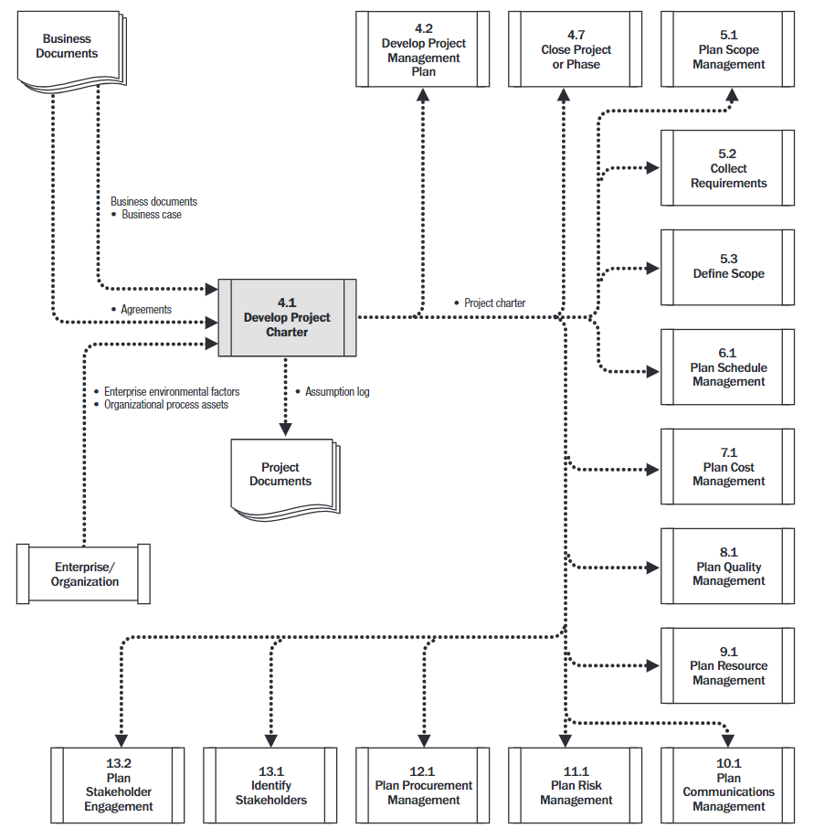
Figure 2.2.1 Develop Project Charter: Data Flow Diagram
(PMBOK, 2017, pg.76)

Data Integration Overview
Data integration refers to the process of integrating data from different sources as well as formats and provide comprehensive data sharing for enterprises and organizations (Lenzerini, 2002). Due to different development time, development departments and operating environment of different software, the data generated by each task are separated from each other (Bergamaschi, 2006). With the development of tasks progress, each task needs previous data to be adjusted. If the data cannot be integrated, project managers will find it difficult to analyse and manage project when data is scattered across various areas. A good data integration system will make the company more efficient. Data integration is mostly manifested by various visual tools. Visual tools have a huge impact on project plan, and even directly affect the speed to market. Real-time data update can be performed by displaying data through virtual tools. In this project, the graphic analysis will be used in people, scope, schedule, budget and risk management.
We will use a table to clearly demonstrate how the information is exchanged between them.
 | People | Scope | Schedule | Budget | Risk
People | / | Scope plan will identify L1 – L4 tasks, which decides how many employees should we have. | Schedule plan will identify the start date and end date, which the people plan should refer to. | The level and numbers of employees will influence the estimation of budget. | The level of employees will be related to technological risks.
Scope | / | / | Tasks will depend on how much time the schedule allocates to them. Meanwhile, scope of project will also help to adjust the decision of planning schedule. | The scope will influence budget directly. More tasks and requirement will need more budget. | If the scope is too large, it will be facing economic risks.
Schedule | / | / | / | Schedule plan will fix the time range for each task. Thus, it will decide how much money the budget plan should allocate to these tasks. | If the schedule is too intense, it may go beyond the expected date and cause the delay risks.
Budget | / | / | / | / | Budget plan will be the main reason whether there is a potential economic risk.
Table 2.2.2 Changed Information between Plans
This assignment will not involve quality management. Quality management will evaluate the qualities of employees and products. The quality of recruitment will influence the budget and risk plans. The quality of products will be influenced by people, scope, and schedule plans.

Overview of standards applied in your project management
Toney and Powers (1997) stated that standardized project management includes many standard practices. We will apply good project management and organization, advanced technology, and leadership to this project.
A good project management and organization will arrange the whole project into one piece and make it easier to control and monitor the whole process.
The advanced technology includes information technology, communication technology and modern tech. We will recruit the expert employees and utilize an effective and secure database prototype.
Finally, we will let professional leaders take control of separated departments, which will bring the client a more smoothy workflow.

Part 2 – A Project Plan for Monash University

Project term of reference
In this part, we will introduce the background of the entire project, the methods to be adopted and how to apply the project governance framework to our projects.

The MoCAS case summary
This project (MOCAS) is developed based on the existing CovidSafe app. As we all know, 2020 is a year full of unfortunate and uncertainty. The impact of coronavirus is huge and worldwide, which means we need to use modern technologies to fight a way to defeat the virus. Due to many efforts that have been made by specialists in various areas, CovidSafe app is developed to assist people to track the movement of infectious people and generate report on the potential risks of social meeting.
But the app has not built a more automated and effective way to manage the data of patients or ordinary people, which is what our MOCAS project will optimize next. There might also be concerns about the privacy of citizens’ personal data. We will store de-privacy personal data by establishing a local database, thereby making the data analysis maintain the security meanwhile become more convenient and faster. Our project will also add the feature of generating reports, which makes it easier for reading and downloading.

The PM Methodology
As PMBOK (2017) indicated, PM Methodologies consists of a series of important project management methods, which will affect the process, progress, communication, and management of the entire project. There are plenty of types of PM Methodologies such as Waterfall, agile SDLC, Hybrid, Scrum, … and so on. We will introduce some of them to help you understand what the PM Methodology is.
For example, the mostly used PM Methodology in traditional project management plan is Waterfall, which as Ajam (2018) states, contains 6 parts: requirement, design, code, test, fix issues, and deliver the product. The project using Waterfall methodology will follow the timeline to complete the tasks. Waterfall methodology has many advantages like straightforward workflow, clear descripted scope, more collaborative teamwork, understanding each department more easily, convenience of reviewing the project. But it also has some shortcomings like lack of flexibility, low effectiveness when one task goes wrong, obstruct of adjusting if customers dissatisfy.
On the other hand, there might be about 20 distinctive Agile methods, according to Rasnacis & Berzisa (2017). Comparing to the Waterfall methodology, Agile SDLC can be more flexible during the whole process. It has 4 stages which are scan, change, respond, and analyse. However, Agile methodology is more difficult for project managers to control the whole process. The iteration process of Agile means that the project needs a high level of integration, which requires managers pay more attention to combine each part of management efficiently.
We will mainly use Waterfall methodology as our project management approach but also refer to Agile SDLC for its flexibility and other advantages.

Project Governance Framework
Dinsmore & Rocha (2012) states that project governance is the framework for the way of decision inside the project. There are three main factors of project governance: structure, people, and information. If we make a decision on developing or adjusting our project, we should always consider these three factors.
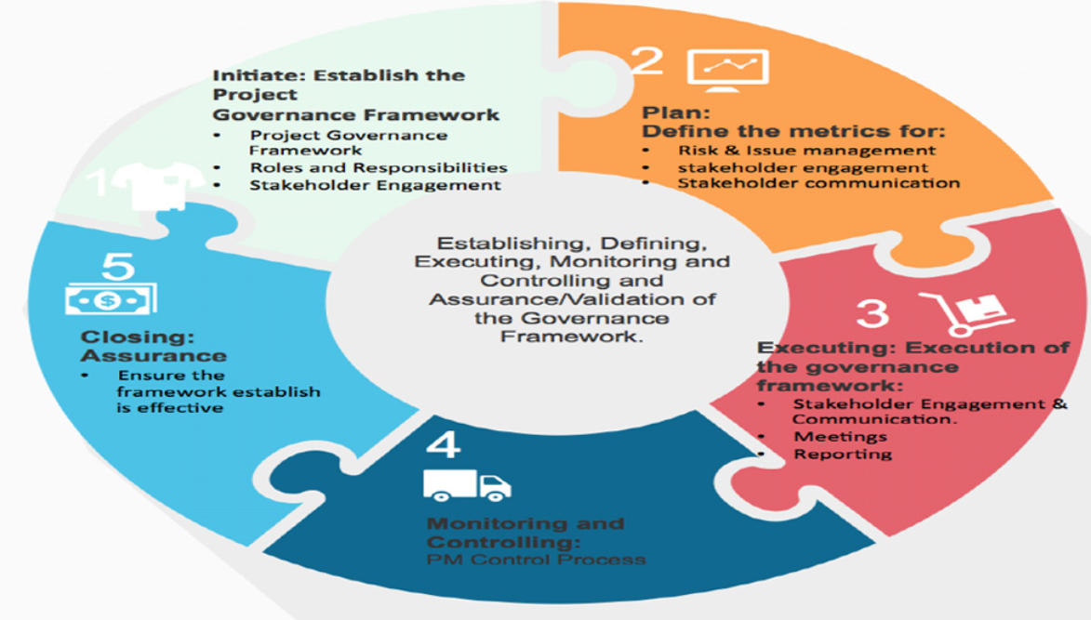
Figure 3.1.3 Project Governance Framework (Alie, S. S. ,2015)
As Figure 3.1.3 shown, there are 8 components in project governance. During this process, we will establish the project governance framework base on the details of the project. We will list out the roles and responsibilities to all stakeholders, and it will come with stakeholder engagement. For example, we will develop a clear set of rights and responsibilities to prevent employees from not completing their tasks on time. And this is how project governance is applied and works.
For detailed oversight mechanisms, we have used a risk management system to manage and control the risk. In this report, we have analysed the risk and their risk response actions that may encounter in the developing process, to reduce the impact and keep up the oversight working. We also implemented stakeholder engagement, come with a stakeholder communication plan, and analysed the stakeholders to minimize the problem in the process of developing.

Project Team Structure
Figure 3.2: Project Team Structure.

Project Objective/s & Business Constraints
Project objectives ensure that the software is moving in the right direction and meets the needs of customers. This software should support requirements from Australia Government, so the project objective should be customer satisfaction. The main requirements include:
1. Extract data from CovidApp including: a) de-identified data, b) COVID-19 test date, c) results of each test, d) follow-up for positive test.
2. De-identified data goes to new national storage database
3. Extract data from national storage database to desktop/SPSS
4. Generate: a) standard reports b) data set for machine learning analysis
There are also some business constraints on this project, including predefined project, freedom to recruit and budget limits. In order to achieve requirements from the Australian Government, the predefined products should be created. Then, this project needs to hire some employees to complete these new requirements. As for budget limits, this project cannot exceed the budget of $800,000. The finishing date is also a challenge. Since we all know that the situation is turning good in VIC, we need to complete the whole project before the government changes its policy, otherwise we may have to fix more aspects in our project like our algorithms or some abandoned requirements. Although we can still update and adjust our product after publishing it, it is still better that we develop our first version of database as soon as possible.

People Management Plans

Planning Assumptions, Constraints & Dependencies
Assumptions
Good cooperation is a key factor in formulating excellent strategies and achieving project tasks (2018). We will assume that suitable and enough employees can be recruited within a certain period, under this epidemic situation. The skills of these employees can meet our requirements, and their own health conditions can support them to complete the entire project.
Constrains
Under the COVID-19 situation, the recruitment process will be lengthened, and the quality of recruitment will be determined by more factors. Some outstanding talents may eventually be unable to join our project due to distance or physical factors.
Dependencies
People management is related to other management. For example, people management requires to know the whole number of employees that the project has to recruit, thus, well-designed scope management will help this to proceed successfully. Or the budget management will give the team the estimated budget to hire the employees. If the budget is not enough, the people that are recruited maybe not suitable.

Methods & Techniques Applied
According to PMBOK (2017), the main methods that will be applied to people management are:
1) Sample basic sender/receiver communication model, 2) Sample interactive communication model, 3) Stakeholder register, 4) Stakeholder Analysis, 5) Stakeholder Engagement Plan, 6) Stakeholder Communications Plan, 7) Project Team’s HRM Plan.

Stakeholder Analysis
A stakeholder is a party that has an interest in a company and can either affect or be affected by the business. (CHEN, 2020) The primary stakeholders in a typical corporation are its investors, employees, customers, and suppliers. However, with the increasing attention on corporate social responsibility, the concept has been extended to include communities, governments, and trade associations. It is important to identification stakeholder because it is necessary to attract every stakeholder to engage with each other to ensure the goal can be achieved at maximum possibility.
According to PMBOK (2017), there is three main way to analysis stakeholders, they are expert judgment, data analysis, and meetings. Two of them have been used to analyse stakeholders in this report because this report has constraints on being able to gather more data during the meeting in the developing process. In the expert judgment part, this report has listed the organization’s approach to managing risk, also including the types of risk that likely to be encountered on these particular projects, such as media influence and social response in particular stakeholders. For the part of data analysis, to determine the risk appetite of project stakeholders, this report listed the assumed salary rate base on the situation that is currently encountered with COVID 19 and the average salary data of Monash University.

Stakeholder Engagement Plan

Stakeholder Engagement Methodology Overview
The approaches finalized with IAP2 frame are
- State what is unique or innovative
- Identify organisation, sector and geographical location
- State engagement objectives, purpose and scope
- State spectrum level
- State engagement method/s and sequence
(IAP2 Australia, 2019).
This Stakeholder engagement plan contain stakeholder engagement strategies, stakeholder communications plan, recruitment plan and training plan.

Stakeholder Engagement Strategies
In this section, stakeholder engagement strategies show as Figure 3.4.1.
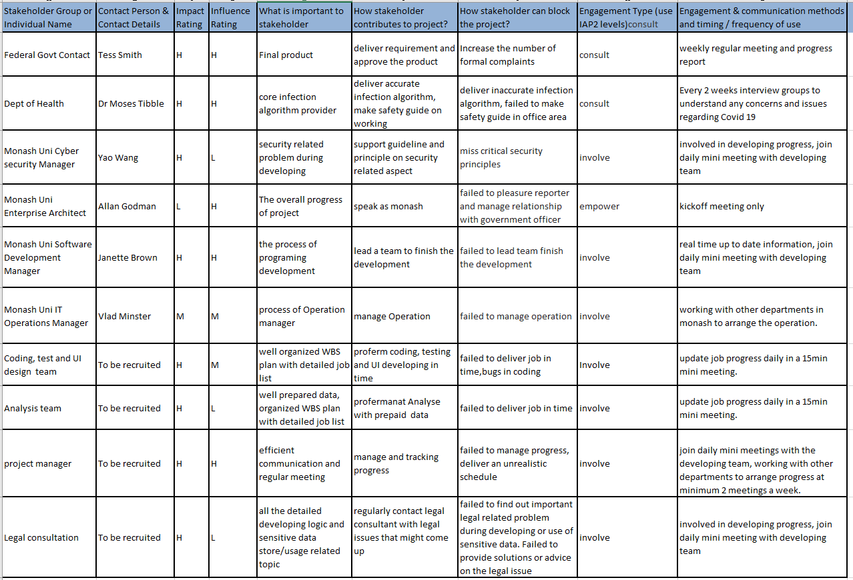
Figure 3.4.1: Stakeholder Engagement Strategies

Stakeholder Communications Plan
The stakeholder communications plan shows that different stakeholders should be reviewing project information on regular basis. The stakeholder communication plans show as Figure 3.4.2.
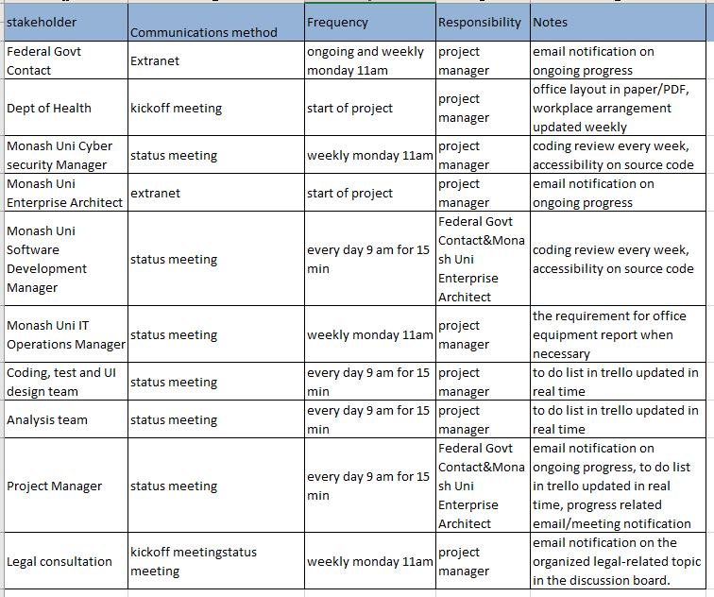
Figure 3.4.2: Stakeholder Communications Plan

Project Team’s HRM Plan
This section is about project team’s HRM plan.

Recruitment Plan
The job positions in my project organisation chart which has not been recruited now has showed in following table. Please see Figure 3.4.3.
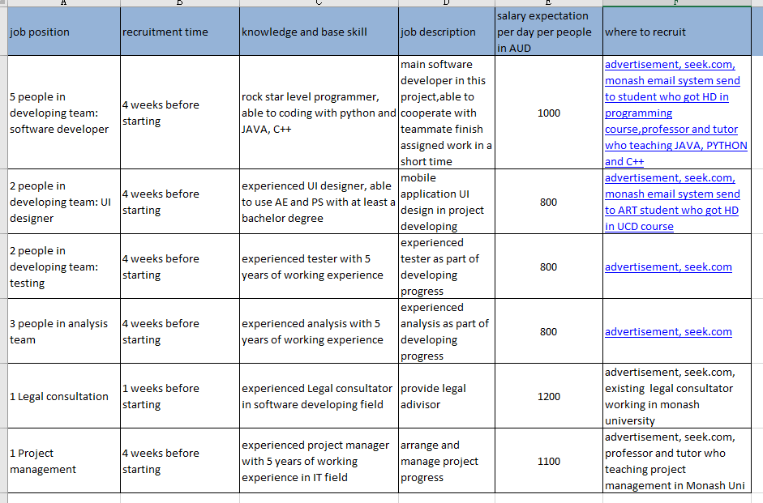
Figure 3.4.3: Stakeholder Communications Plan

Training Plan
The training needs of my project team has been identified and provided in following table. Please see Figure 3.4.4.
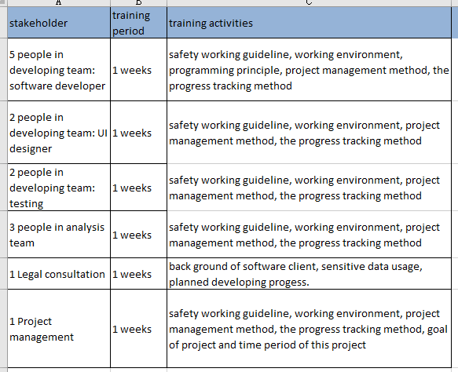
Figure 3.4.4: Training Plan

Scope Management Plan

Planning Assumptions, Constraints & Dependencies
In this section, all the following plan are based on Assumptions that: It requires analysis of information contained in the project charter; All the requirement must be analysed before defining scope management plan; All the business needs and dialog must use the licensed product, and security department must be involved in every step. The assumptions are based on the analysed information, real-life relationship of stakeholders, previous similar project and information in the industry.
This scope management plan is constrained by a variety of fact, the developing time should not more than 6 months since it highly time-sensitive, also the system will only be able to support limited language due to the short of developing time.
For the dependencies, this project depends on a virtual working environment because most likely people must work from home, the mock data also depend on Victoria data warehouse.
Methods & Techniques Applied
According to PMBOK (2017), the main methods applied to the scope management plan will be product scope, including requirements traceability matrix, Work scope and WBS scope.

Methods & Techniques Applied
According to PMBOK (2017), a scope management plan is a component of the project management plan that describes how the scope will be defined, developed, monitored, controlled, and validated. the main methods applied on scope management plan will be product scope, including requirements traceability matrix, Work scope and WBS scope.

Product Scope
In product scope, apart from the methodology used before like expert judgment, the overall software design approach that was applied to identify the functional and non-functional makeup was mainly product analysis listed in PMBOK(2017). The report breaks down the product structure, analysed the requirements from the scenario, and the system based on expert judgment.
With this approach, the requirements are summarized in the following paragraphs.
For Functional requirements:
System should be able to extract data from Victoria COVID-19 App.
De-identified data should go to new national storage database
System should be able to Extract data from new database
System should be able to import Data goes into software
For non-functional requirements:
System should be able to be running in both windows and MacOS.
System should be able to access as Web application.
System should be able to push notification base on government announcement.
According to this workout, requirements traceability matrix has provided as following Figure 3.5.3.
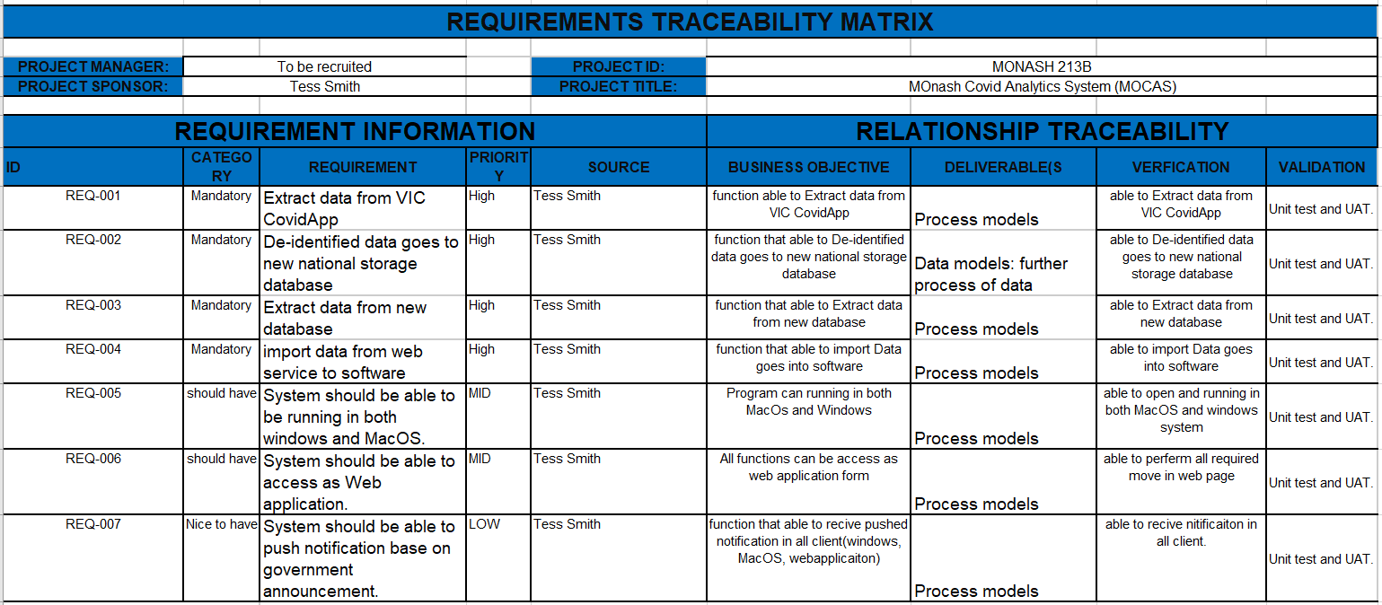
Figure 3.5.3: Requirements Traceability Matrix

Work Scope
In this section, the WBS finalized with SDLC-waterfall approach.
SDLC is a process followed for a software project, it consists of a detailed plan describing how to develop, maintain, replace and alter or enhance specific software. This report will focus on the development part rather than maintenance.
Waterfall approach was first SDLC Model to be used widely in Software Engineering to ensure success of the project. In "The Waterfall" approach, the whole process of software development is divided into separate phases. In the Waterfall model, phases are listed sequentially.
Due to the diagram size, the WBS can be seen on page 27.
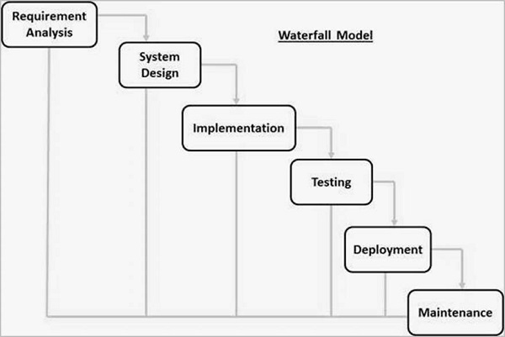
Figure 3.5.4.1: Waterfall Model Based on SDLC

Accuracy of Product & WBS Scope
The overall Accuracy of Product and WBS Scope targeted at 60%, most of the uncertainty comes from the lack of details and polish on requirement gathering, but there is no problem with the overall structure and framework. As the situation changes, this scope management plan will update with progress of the project and re-editing to meet the new requirements.

Change Management Approach
If the client wants to reschedule the project, we will make the change according to the changing requirements.
First, after the request has been submitted, we will analysis the impact, see how it affect the overall progress of the developing progress. In this case, we will have to approve all the request submitted by client, so we will implement changes immediately.
in terms of products, we will change the L1 products and testing/implementation sign offs. This is because we need to reconsider what main product we should keep, add, and discard.
Second, in terms of schedule, we need to change the time duration for some specific products. Most of them are in L2 to L4, but we do not have to change much in L3/L4 since it will still have the same structure. We only have to move the start/end date for them all.
After that, we review the process, and reset our milestone since the whole project schedule has been changed, and a report will be come out based on all the changes made.
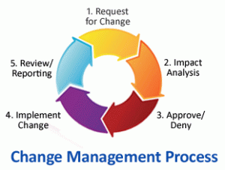
Based on all the information and methods, the scope management plan has been finished.

Figure 3.5.6: Change Management Process
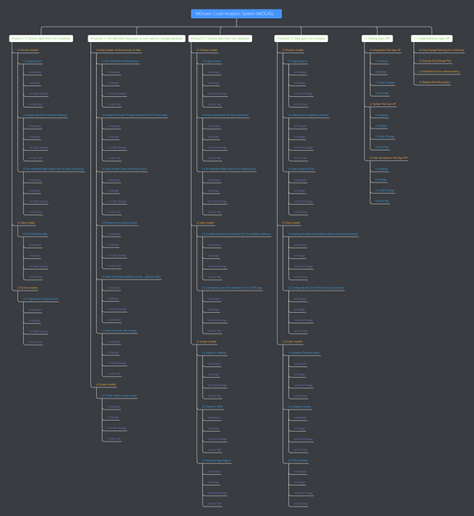
Figure 3.5.4.2: WBS
(High resolution version can be access at: https://mubu.com/doc/1-t-fJoRlCB#m )

Schedule Management Plan
Schedule management plan will help us to identify all the activities that need to be done and order them in a proper way. In this session, we will estimate the time duration for each activity of developing MOCAS, schedule the detailed date of start and end, and monitor the whole process. In addition, we will also consider the backup schedule plan for unexpected situations.

Planning Assumptions, Constraints & Dependencies
This schedule management plan is based on the following assumptions.
- We assume that our project will begin on 11/02/2020 and end on 01/20/2021. The whole duration will be 80 days including weekends.
- We assume that our employees will not be working on weekends due to labour law.
- We assume that all the tasks from L1 to L4 will be assigned to the proper staff, which means that we do not need to schedule extra time for delay of the process.
- We also assume that every staff who we hire is healthy enough to finish their jobs, thus no need to consider the time that we spend on recruiting a new employee.
We are currently under a special situation where the coronavirus is influencing the whole world. As the latest report from Victoria (2020), the lockdown of Melbourne will be gradually liberalized, but contact and movement are still causing a lot of trouble. These are the main constraints of our developing process. Under these circumstances, communication between employees will become more difficult, which reduces the efficiency of scheduled plans. The restriction of face-to-face meeting is also a constraint. If something happens to one employee, and the online meeting cannot resolve the instant urgent situation, there will be more time needed to continue the project.
There are 4 types of dependencies inside schedule management which are finish-to-start, finish-to-finish, start-to-start, start-to-finish. Most types of dependency between these scheduled tasks is finish-to-start. For example, we want to finish L2 process models before the start of L2 data models because only when the process ends, will the data analysis begin. There are also some tasks having start-to-start dependency. For instance, some of the L4 activities have similar design and coding, thus we can start to develop them at the same time.
The dependencies between managements are also significant. The recruitment process in People Management will require to estimate the total number of employees, which will depend on the schedule of each task. The schedule of required tasks will affect the previously drawn WBS diagram, which means the Scope Management also depends on Schedule Management. This schedule will also influence the budget management to decide how to allocate the resources and estimate the total budget. Finally, schedule management is also an aspect that risk management will consider about.

Methods & Techniques Applied
As mentioned in PMBOK (2020), there are plenty of methods that we can apply to our schedule management. We will use backlog for iterative scheduling and on-demand scheduling methods to build the original scheduling structure and update it constantly.
PMBOK (2020) also teaches us that iterative scheduling with the backlog is often used as a shape of rolling back and forth with an arrangement based on versatile life cycles, such as the spry approach for item advancement. This method is frequently utilized to provide incremental esteem to the client or when numerous groups can concurrently create a huge number of highlights that have few interconnected conditions.
The on-demand method is based on the theory-of-constraints and motivation-based planning concepts from incline fabrication to constrain a team’s work in advance in order to adjust the request against the team’s conveyance throughput. On-demand planning is regularly utilized for ventures that advance the item incrementally in operational or sustainment situations, and where assignments may be generally comparative in estimate and scope or can be bundled by estimate and scope. These methods will benefit us by generating high-quality and lower-risk reasonable and feasible schedules (Szőke, 2009).
We will also use millstone and a work package – lowest level of detail within the WBS (Jones,E. F., 2009) to configure our scheduling plan.
Our main software to schedule the plan and manage the progress are Microsoft Project and Trello. The graphs that we will use are PERT Network Diagram, Critical Path and Gantt Diagram.

PERT Network Diagram
As PMBOK (2017) stated, a PERT network diagram can visually represent an arrangement of occasions that must happen inside the scope of a project’s lifetime. It can clearly help us to see what have been done and what have not. Most importantly, a PERT diagram can show us the relationship and dependency between all the activities.
The PERT diagram can help the manager to calculate and save time and resources efficiently. If we do not use PERT diagram and schedule all the tasks one by one by simply applying finish-to-start dependency, it will take much more tedious time to finish the project. With a PERT diagram, we can now figure out what can be done at the same time, which will absolutely accelerate our project.
Our PERT diagram will be shown below. See Figure 3.6.1.
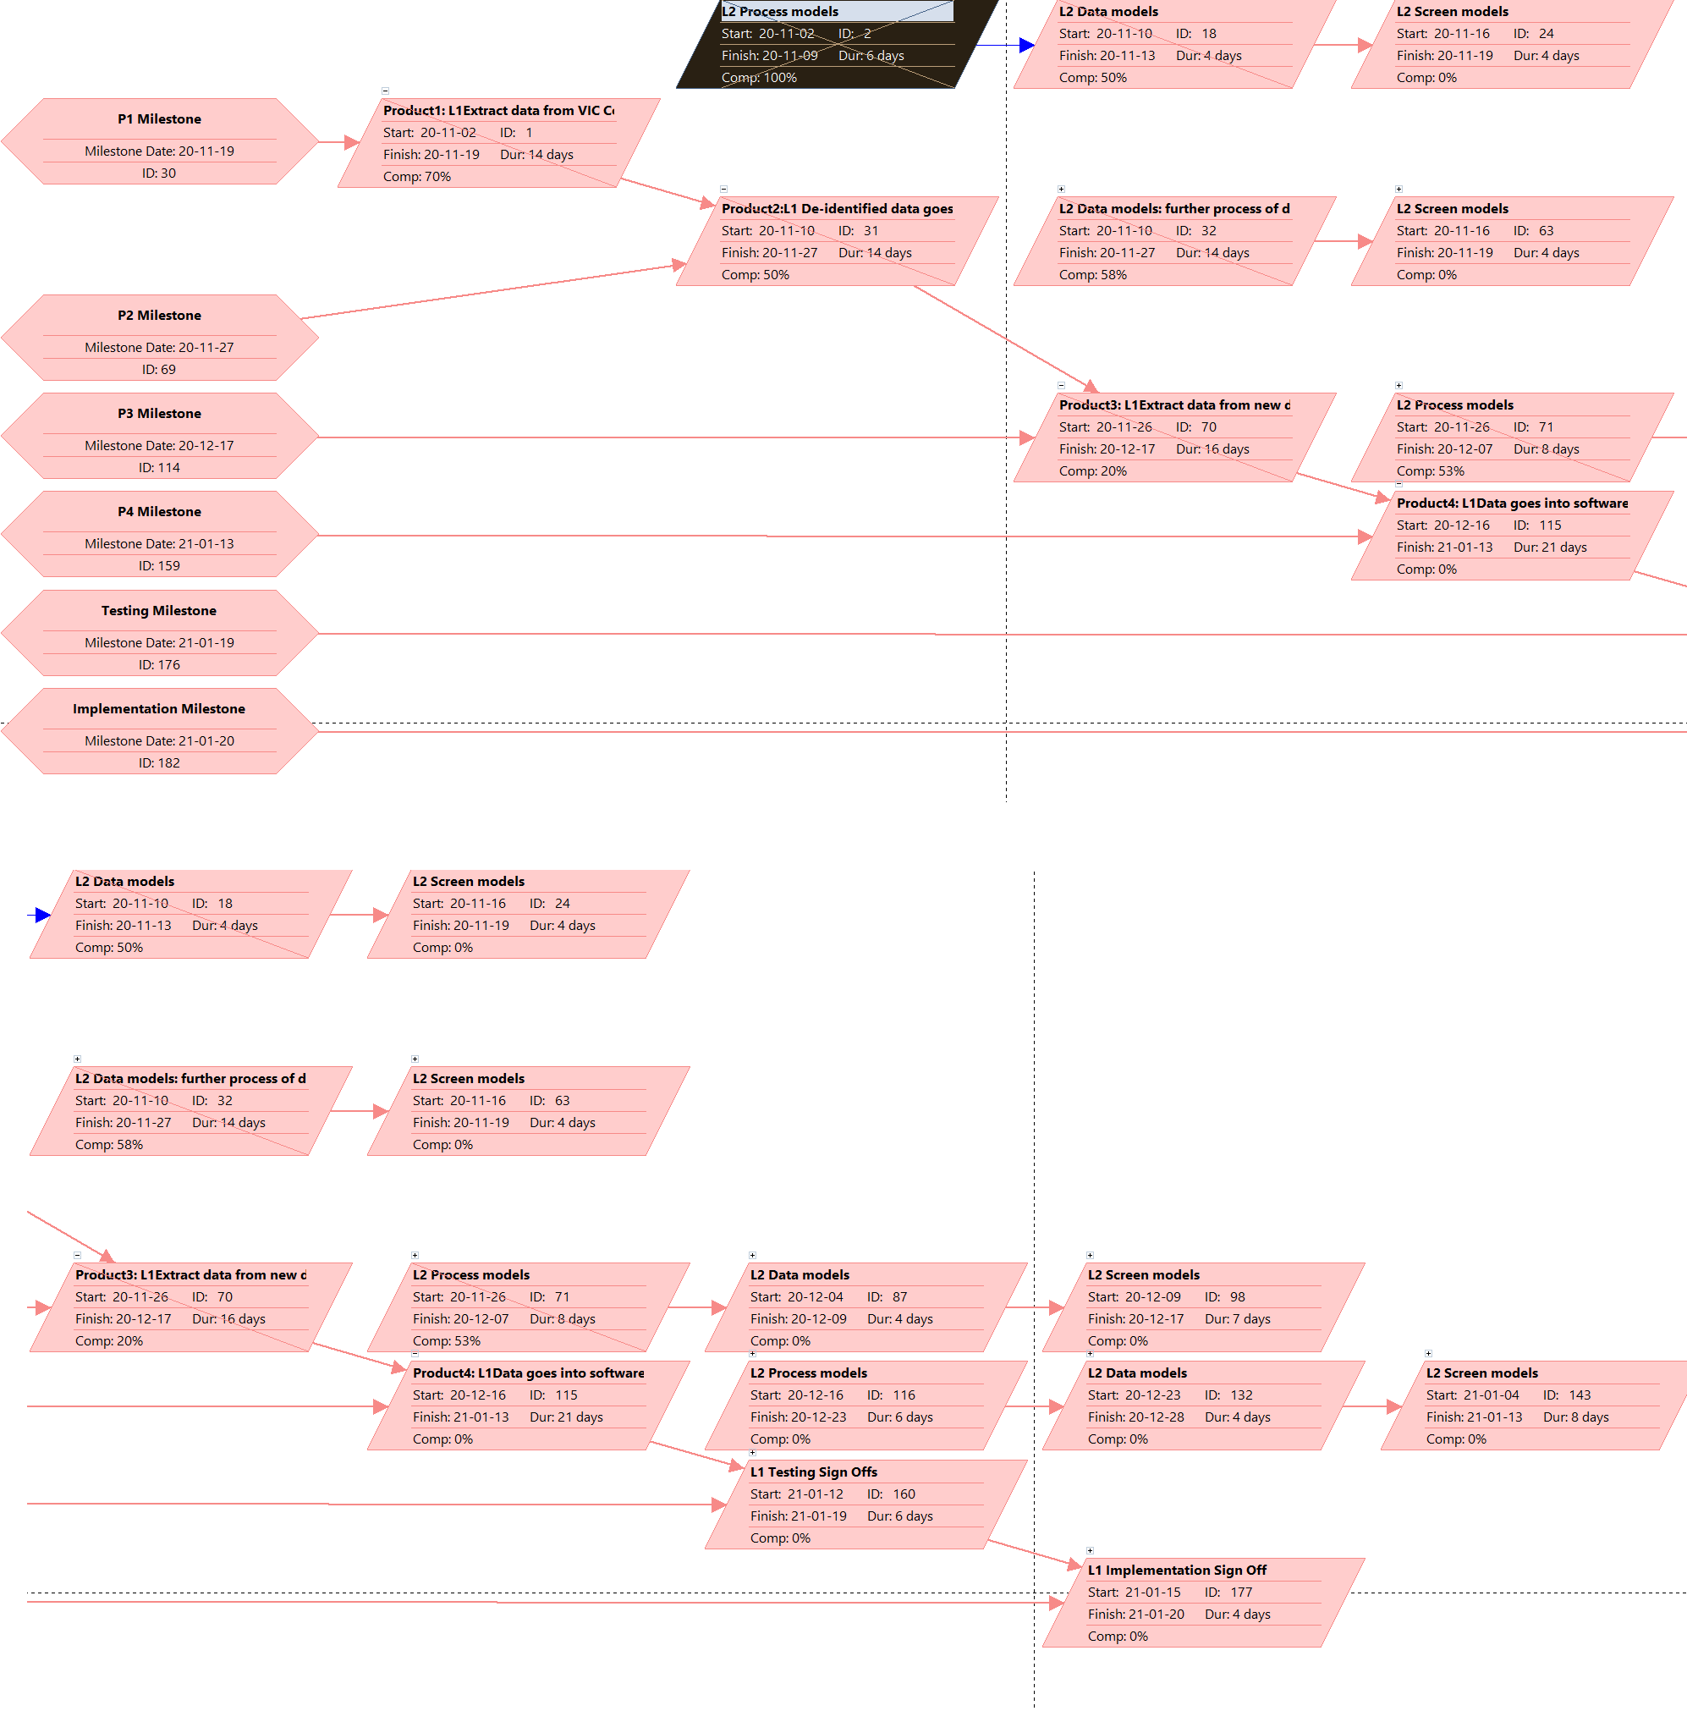
Figure 3.6.1 PERT Diagram

Critical Path Discussion
PMBOK (2020) introduces that the Critical Path is utilized to assess the least project length and decide the sum of plan adaptability on the logical network path inside the scheduling plan. There are a few essential benefits that a critical path can bring to our project.
It can show us the critical and noncritical tasks visually and clearly, which will help to identify the most important task that we should focus on. This will also save managers’ time to configure the timeline in a better and efficient way. A critical path will compare and demonstrate the theoretical plan and the process in reality. Combined with PERT diagram, the critical path can indicate the dependencies between each activity, too. In addition, it is a useful way to make a critical path to take control of our project. Thus, a critical path will eventually prevent us from exceeding our time.
Our CP diagram will be shown below. See Figure 3.6.2.
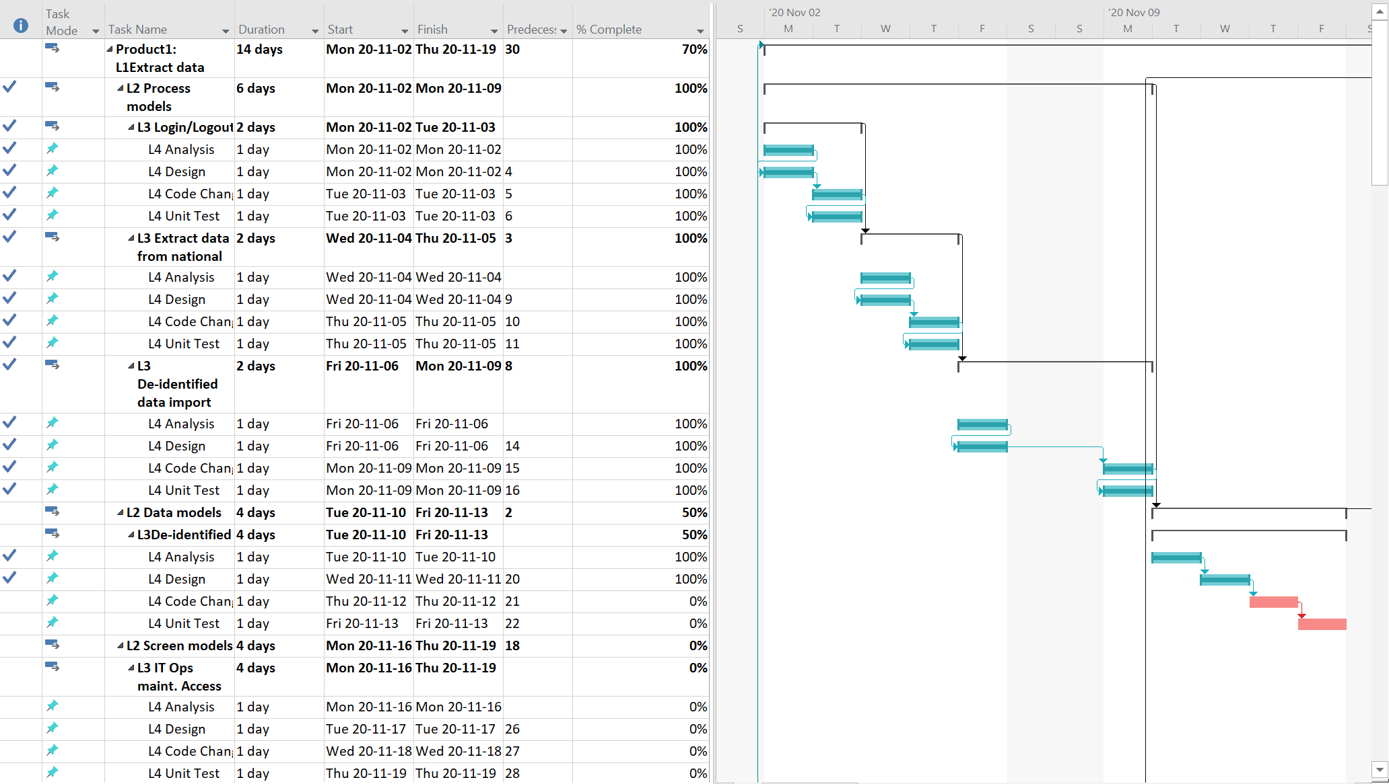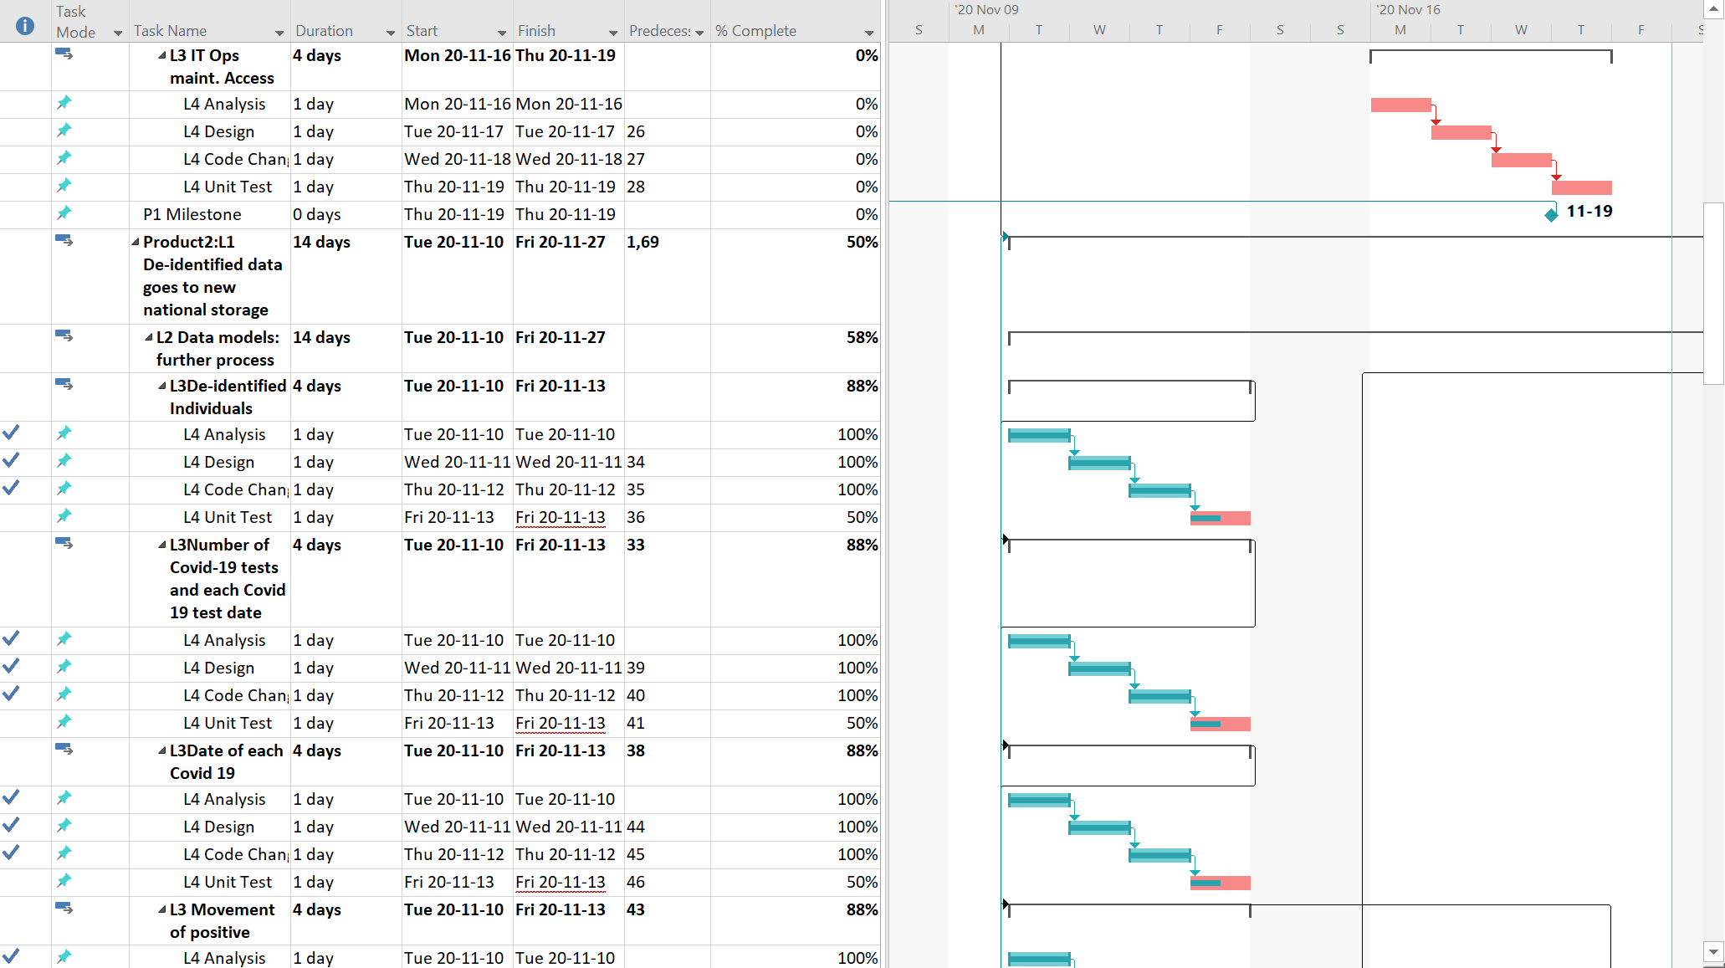
Figure 3.6.2 Critical Path Diagram

GANTT Chart Overview & Attachment
Our Gantt Chart shows the whole project scheduling plan.
There are 6 L1 tasks containing 4 L1 products, testing sign offs and implementation sign offs. Product 1 contains 3 L2 activities and a milestone at the end of Thu 20-11-19. Product 2 contains 2 L2 activities and a milestone at the end of Fri 20-11-27. Product 3 contains 3 L2 activities and a milestone at the end of Thu 20-12-17. Product 4 contains 3 L2 activities and a milestone at the end of Wed 21-01-13. The testing sign offs contains 3 L2 activities and a milestone at the end of Tue 21-01-19. The implementation sign offs contain 3 L2 activities and a milestone at the end of Wed 21-01-20.
L3 and L4 activities are most detailed activities in our scheduling plan. Thus, we will use these activities like design, code, implement, to recruit the employees and estimate the budget.
Our Gantt Chart will be shown at the end of this section. See Figure 3.6.3 in 3.6.8 – Related Graphical Material. The whole schedule can be seen within the 5057 Assignment2 Schedule Management MS Project file attached.
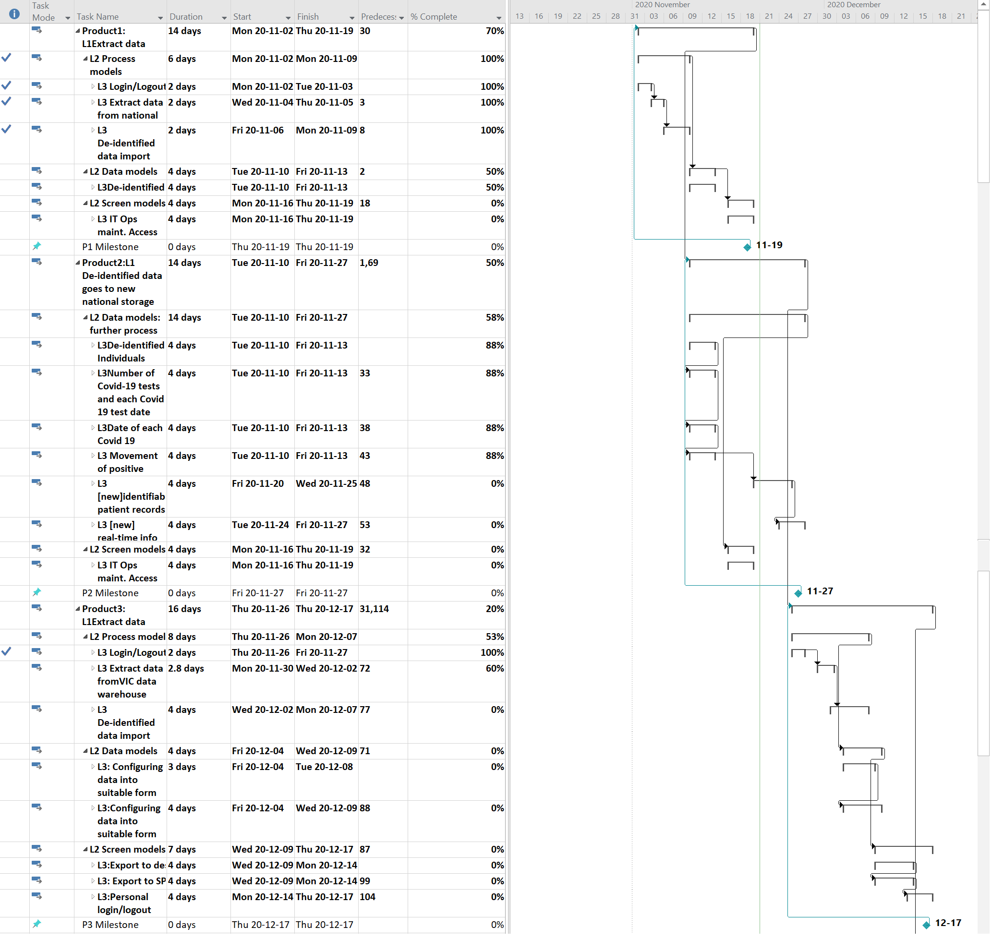
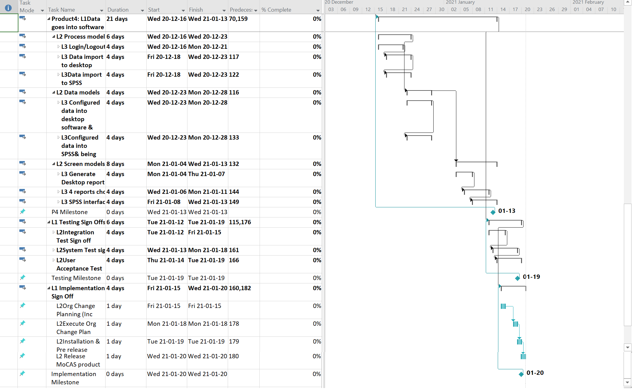
Figure 3.6.3 Gantt Chart

Accuracy of Schedule Plan
We estimate that our schedule plan is about 85% accurate of the actual process.
The reason why this score is this high is that we have already covered quite a lot details and considered lots of situations that might happen in the future. We have demonstrated the assumptions, constrains, and dependencies of schedule management and made PERT Network Diagram, Critical Path, and Gantt Chart to specify the schedule. The milestones are also helpful to make the whole process more structural. It is clear enough for managers and employees to follow the instruction and do their job.
We will try hard not to change the schedule frequently because changing is painful, and it costs a lot of money and efforts. Also, since we are mainly using a Waterfall PM methodology, the schedule accuracy should be preserved at a high level. So, we try to plan the schedule early and do our best to avoid any possible risks.

Change Management Approach
If the client wants to reschedule the project, we will make the change according to the changing requirements.
First, in terms of products, we will change the L1 products and testing/implementation sign offs. This is because we need to reconsider what main product we should keep, add, and discard.
Second, in terms of schedule, we need to change the time duration for some specific products. Most of them are in L2 to L4, but we don’t have to change much in L3/L4 since it will still have the same structure. We only have to move the start/end date for them all.
Finally, we have to reset our milestone since the whole project schedule has been changed.

Budget Management Plan

Planning Assumptions, Constraints & Dependencies
The characteristics of project is long cycle, huge investment and high risk, so cost management has always been the focus of investors and project stakeholders (PMBOK, 2020). Ji argues that budget management is an indispensable part in project management, and even can directly determine the profits and development trend of company and organizations (Rowland, 2019). Therefore, it is necessary to manage budget reasonably in every project.
There are three main models in MOCAS application, including process models, data models and screen models. According to the structure of this project, this project requires 11 positions (Table 3.7.1).
Position Title - |  | Experience Level | Metric | Metric
Software Development |  | Intermediate | $1,000 | Per man day
UI Designer |  | Intermediate | $800 | Per man day
Testing |  | Intermediate | $800 | Per man day
Project Manager |  | Intermediate | $800 | Per man day
Business Analyst |  | Intermediate | $800 | Per man day
Legal Consultation |  | Intermediate | $1,200 | Per man day
Table 3.7.1

Costing methods & techniques
There are some methods to manage budget, including top-down estimation, bottom-up estimation, analogous estimation, parametric estimation and three-point estimation. Each method has advantages and disadvantages, so it is required to analyse budget, timeline and stage of project to adopt suit approach.
1. Top-down estimation
Top-down estimation is to divide the whole task into smaller tasks and plans, and estimate the cost of every tasks and plans (Aston, 2019). The top-down estimation is commonly used in initial stage of strategic decision-making, mainly because it does not require accurate duration and cost. Rowland(2019) argue that top-down estimation can use previous project information and data to avoid unforeseen risks. Then, this method is inaccurate, and it may be huge different from the real budget. As for advantage, the top-down estimation can calculate the cost faster, and it can help customer or manager determine whether their budget is feasible
2. Bottom-up estimation
Bottom-up estimation is to divide customer needs into small tasks and calculate the cost of small tasks to get the total budget(Aston, 2019). This method is the opposite of top-down estimation. The benefit of the bottom-up estimation is that it can help project manager get the WBS of the project. Rowland(2019) think that the estimated budget of bottom-up estimation is more realistic and accuracy compared with top-down estimation, and bottom-up estimation can make people more acceptable. The disadvantage of bottom-up estimation is time-consuming, and it required project manager to get understand of all details of every tasks.
3. Analogous estimation
Analogous estimation is to use data from previous similar project, including duration, budget, weight, to estimate the budget of current project (PMBOK, 2017). Analogous estimation is east and quick, but the disadvantage is that the accuracy is relatively low. Aston(2019) argue that analogous estimation is inaccurate and rely too much on previous data.
4. Parametric estimation
Parametric estimation uses the parameters of other similar projects to evaluate the current project. Parametric estimation is more accurate than analogous estimation, mainly because this estimation uses the relationship between data and variables between multiple data sets (PMBOK, 2017). The most important thing is that it is difficult for digital projects to find suitable data sets.
5. Three-point estimation
Because single-point estimations may be full of uncertainty and risks, three-point estimation is adopted by project manager in budget management. Three-point uses the average of worst budget value, best budget value and most likely budget value to get the expected budget estimation(PMBOK, 2017). This estimation can be used in budget management to reduce risks, and manager can consider risks and uncertainties from best, worst and expected budget value. Due to requirement of three budget value, this method takes more time than other techniques.
Considering duration, this project does not need a long time, so three-point estimation is not suitable for this project. As for accuracy, the result of using top-down estimation is inaccuracy, so top-down estimation will be excluded. Analogous estimation and parametric estimation both need previous project, so finally bottom-up estimation will be selected.

Budget Overview
Budget overview summarizes all expenses of MOCAS system, including direct cost and indirect cost. As for direct cost, labor salary, software cost and training cost should be included. In indirect cost, it can be divided into hardware cost and utilities cost. In order to prevent accidents in this project, a reserve is needed.
 | Units/days | Subtotals | WBS Level 2 Totals
WBS items
1.Labor |  |  | $150,000
2. Software |  |  | $40,000
2.1 Software purchase | 56 days | $30,000
2.2 Server | 56 days | $10,000
3. Hardware |  |  | $123,000
3.1 Computers | 50 | $100,000
3.2 Furnitures | 100 | $20,000
3.3 Printers | 5 | $2,000
3.4 Sanitary tools | 5 | $1,000
4. Utilities |  |  | $45,000
4.1 Rent | 56 days | $20,000
4.2 Electricity | 56 days | $10,000
4.3 Water Fee | 56 days | $5,000
4.4 Internet Fee | 56 days | $10,000
5. Training |  |  | $40,000
5.1 Training | 15 | $30,000
5.2 Travel | 10 | $10,000
6. Reserve(20% of total estimate) |  |  | $120,000
Total project cost estimate |  |  | $518,000

Budget By Time Period View(s)
The total labor cost is shown as:
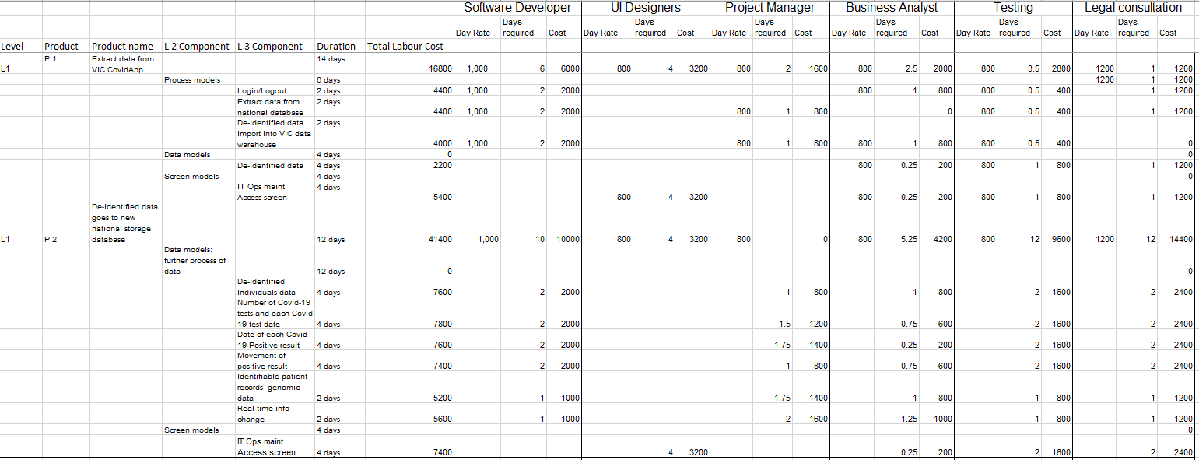
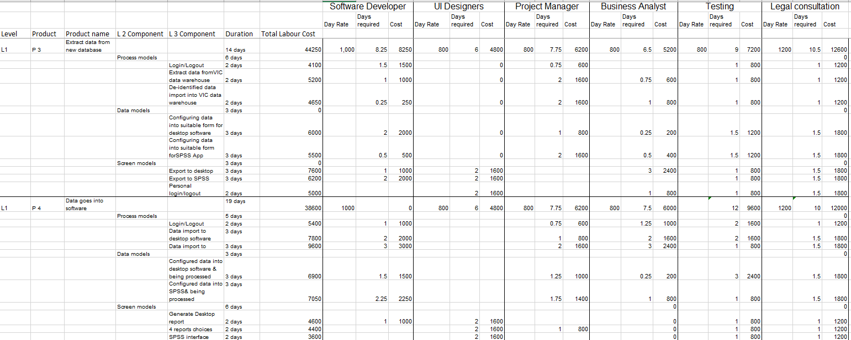
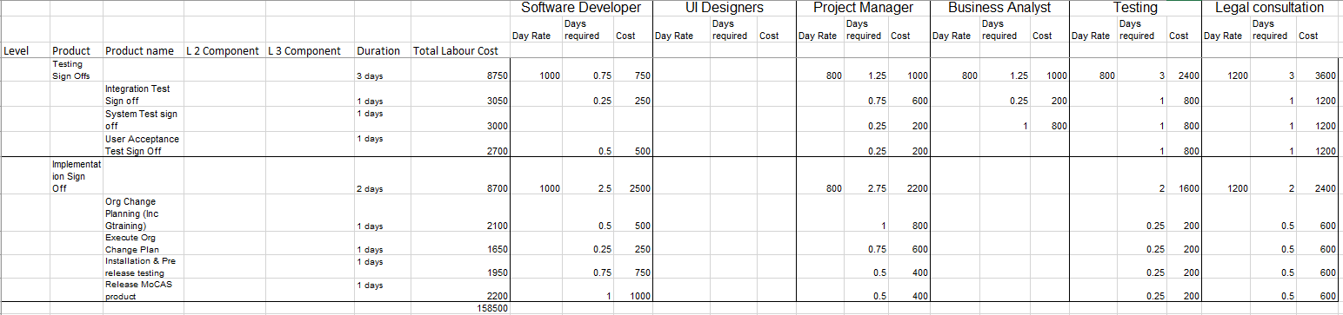

Accuracy of Budget Plan
The budget accuracy of this project is affected by estimation accuracy and provision for the cost of risk management. This budget cost model is based on WBS structure, and each budget is calculated based on labor’s working hours and salary standards. The labor’s cost account for 38.6% in total project. The cost of software and hardware account for 26%, and these costs are fixed consumption. These costs may be 5% different from the real costs. The daily cost is utilities. The duration may be longer than expected time, so there is 3% margin of error. The final part is training part, it requires 7% of total cost. The cost of training may be 3% margin of error.
As for provision for the cost of risk management, it accounts for 17% of total cost estimation. This value is close to the excepted value of 20%. In total, the accuracy of budget model is 86%. The realistic cost estimates should be 10% different from cost estimation (PMBOK, 2017). Although there is a gap with the ideal value of 10%, it is generally more accurate.

Change Management Approach
If the customer wants to change the budget plan, the part of software and hardware should remain unchanged. The main reason is this part of the expenditure is fixed and cannot reduce budget. Another variable cost is utilities, and this part of the expenditure is calculated according to the daily maximum. Normally, the budget of utilities is relatively sufficient, which is 20% higher than the actual value used. The final variable budget is the cost of labor, project managers can appropriately adjust employee wages.

Risk Management Plan
PMBOK (2017) states that all projects have certain risks, because there are too many uncertain and complicated factors in the project. Some are artificial and some are natural. Thus, Risk management is an essential part of project management. The main purpose of risk management is to avoid or decrease the potential risks by some managing methods or techniques.

Planning Assumptions, Constraints & Dependencies
Assumption
- We assume that the previous management – people, scope, schedule, and cost – have already taken the potential risks into their consideration and leave some space for us to rearrange the project under some unexpected situation.
- We assume that we are able to overcome the potential risks on our own rather than looking for help from other big organizations/communities.
- We assume that the other teams that compete with us will face the similar challenges that we will face.
Constraints
We are currently in the stage of a global lockdown, which adds a lot of resistance to the operation of the project. One of the obstacles to developing risk management is the uncertainty. We may meet a whole new challenge that we have never met before under this situation. This shows that we can’t make risk management exactly the same as before.
Dependencies
There are 7 aspects insides dependencies of risk management: general dependency risk, security risk, deadline risk, software dependency risk, process risk, boundary risk & dead-end risk, and agency risk.
Risk management will also depend on all the previous management. For example, a failed executed schedule plan will bring the project risks. Or a failed budget calculation will put the whole project in the situation where it is running out of money.
As Sankararajan & Shrivastava (2012) states, the main difference between issue and risk is that issue has already happened, but risk is something that has potential to happen. Since issues have already happened, what we should do to deal with issue is finding a way to fix the problem and minimize the loss. On the other hand, the mitigation that should be done to prevent risks is to find some strategies to avoid the happening of risks.

Risk Management Methodology, including details of methods & techniques
There are 4 main methods we will apply to risk management.
1) Identify risks - PESTLE analysis approach
PESTLE analysis is a framework that help us to evaluate the overall level of risk in a project. PESTLE stands for Political, Economic, Social, Technological, Environmental, Legal, Ethical. Political risks are related to the changing local policies. Economic risks may result from interrupt of budget supplying. Social risks can be some public relationship trouble. Technological risks are about some issues that caused by technology aspect. Environmental risks may refer to the external situation like COVID-19 lockdown. Legal risks sometimes are contributed by ignorance of law. And the ethical risks might be caused by some moral issue during the development process. All of these are the aspects of risks that might happen.
2) Rate risks – qualitatively & quantitatively: risk severity findings
When we rate the risks, we can start from both qualitative and quantitatively aspects. As PMBOK (2017) stated, performing qualitative risk analysis require us have a sense of detecting the potential risks. The risk managers should always be aware of the risks that come from each aspect of project management. A good way to evaluate the risks qualitatively is to make a risk document. We should also consider the enterprise environment and the situation of the organization.
For quantitatively risk analysis, we will mainly focus on risk severity findings, which is a method to give all the risks some marks of severity. The details will be introduced in the following 3.8.3.
3) Plan & implement risk response - risk response & delegation arrangements
As PMBOK (2017) indicated, planning risk response is a strategy that can help us to find the potential risks and make the corresponding countermeasures early. Implementing risk response, on the other hand, is taking some practical action to preserve the project from the risks. The benefit of planning and implementing risk response is that we will detect and defend the risks in an early stage of the project to avoid the waste of budget. The main method that we use will be risk response and delegation arrangements. The details will be introduced in section 3.8.4.
4) Monitor risks - risk register dashboard elements
Monitoring risks is the last method we will use in risk management. It will monitor the implementing response process, analyse new risks, and suggest how efficient the response is. The main method we use is risk register dashboard elements, which will be introduced in section 3.8.5.

Risk Severity Findings
Risk severity is a method to calculate and rank the severity of risks. We can divide the risk severity into several levels and use calculation to quantitively measure the degree of the risks.
According to Management of Health and Safety at Work Regulations (1999), the risk severity calculation diagram can be used like this:
Figure 3.8.1 Risk Severity Findings Standard
So, we can calculate the risk severity of following examples by using this diagram.
Risk | Example | Rate score | Severity type
Political | Under situation of COVID-19, due to the lockdown policy and travel ban, some infrastructure might not be supplied on time. | Unlikely, since we can use local supply chain. But it’s a serious injure.  2 * 3 = 6 | Medium risk.
Economic | If government think we don’t need that much money anymore and reduce our budget, there might be economic issue. | Most likely, since COVID-19 is increasingly controlled in VIC. Major injuries.  4 * 4 = 16 | High risk
Social | There are some employees cannot get along well with each other thus they delay the whole group’s progress. | Unlikely, since we will carefully select our employees. Slight injuries.  2 * 2 = 4 | Low risk
Technological | It’s hard to develop a new database that with de-identify feature. The developer may can’t find a proper algorithm for implementing this. | Most likely since technology area is fully of challenges. Serious injuries.  4 * 3 = 12 | High risk
Environmental | Under this COVID-19 situation, most of our employees will work from home. The working environment may cause depression, due to which the employees may not be able to work. | Likely since lots of people have mental problems during this COVID-19 situation. Slightly injures since we can have backup team members.  3 * 2 = 6 | Medium risk
Legal | The data protection law in Australia may require us provide more secure privacy preserving mechanism, which will cost more time, human sources, and budget. | Unlikely since this has already been considered in the requirement. And we have our lawyers. Serious injuries.  2 * 3 = 6 | Medium risk
Ethical | Using private data without asking permission will have an ethical problem. | Unlikely since we will ask permission from University ethical review department. Slight injuries. 2 * 2 = 4 | Low risk
Figure 3.8.2 Risk Severity Findings Table
Person’s Name | Risks ID & Short Description | Risk Mgt Role and Responsibility | Risk Management Availability (%) | Contact Details
Vlad Minster | 001-area power off | build and maintain UPS system for office area, backup files to cloud service regularly | 95% | Vlad.Minster@monash.com
Dr Moses Tibble | 002- COV19 infection | build temperature test and employer tracking system, wearing N/KN95 face mask in office | 97% | Moses.Tibble@monash.com
Yubo Liu | 003-delay on progress | progress management system | 10% | Yubo.L@monash.com

Risk Response & Delegation Arrangements
Figure 3.8.3 Risk Response & Delegation Arrangements

There are 3 people in charge of the monitoring the mitigation progress of risk management: Vlad Minster, Dr Moses Tibble, and Yubo Liu. Vlad is responsible for the area power off, Moses for COV19 infection situation and Yubo for delaying on progress.

Risk Register Dashboard Elements
This diagram shows us the whole risk management process. We can see who is in charge of which part in the risk management by looking at Risk ID and Statement, and who is the main reason for this risk can also be found at Risk Owner.
We’ve seen that security severity can be calculated by probability * impact. In this diagram, we divide the degree of risk into Low/Medium/High, then we calculate them to generate a Risk Score.
Finally, we will use the risk score to analyse the risk and develop a strategy or a more detailed action to prevent the happening of the risk.
Figure 3.8.4 Risk Register Dashboard Elements

Accuracy of Risk Management Plan
We estimate that the accuracy of this risk management can reach 75%. The remaining part is because in the case of the epidemic, many situations are difficult to predict.
The six session in our cost management has calculated the reverse budget, which can be used to implement the risk management. So, we estimate that there can be 100, 000$ to be utilized to develop this risk management.
The cost of risk management is mainly to configure sufficient security infrastructure, additional funds required in the process of monitoring risks, and to pay the additional salary of the security manager. This budget can be included in the reserve funds, so that there will be some surplus in the reserve funds to deal with emergencies.

Change Management Approach
We need to pay more attention to the political, legal, and ethical risks during the epidemic situation. Because of the changing epidemic, the country’s policies on transportation, social interaction, technology, and privacy may change. This will bring many new problems and challenges. At the same time, with the increasing use of data privacy, potential legal and ethical issues will gradually surface.
If clients change the requirements, we also need to focus on risk management in these areas that are more prone to problems.

Project Planning Conclusion
This project plan demonstrated the whole process of development of MOCAS project – a database system that will bring some new features of dealing with data and integrate into CovidApp.
Our plan combined Waterfall PM methodology and Agile SDLC methodology together to generate a clear structure of development. The sub-plans include: People management, Scope management, Schedule management, Budget management, and Risk management.
People management specified the recruitment plan, communication tools, and the responsibilities. Scope management demonstrated the requirements and tasks in a clear WBS structure. Schedule management indicated the start and end date of this project, and how much time will be allocated to a particular task. Budget management estimated the total budget and left some space for extra budget. Risk management identified and evaluated the potential risks.
This is a mature project plan that will bring you a highly completed product. By implementing this project plan, we will present you a faster, more efficient, and more secure database that can preserve both individual privacy and the effectiveness.
In addition, you can still add more requirements or make some change to our plan but taking our plan as your choice will benefit you from many aspects. If you are interested in our project plan, please contact us by the provided email to talk about more details. All the teams will stand by.
We do hope the COVID-19 situation will be overcome soon by the whole society together. Summer is coming, and so is the normal life.

Reference List (APA)

Alie, S. S. (2015). Project governance: #1 critical success factor. Paper presented at PMI Global Congress 2015—North America, Orlando, FL. Newtown Square, PA: Project Management Institute.

Ajam, M. A. (2018). Organizational Project Management. Project Management beyond Waterfall and Agile, 51-54. doi:10.1201/9781315202075-9

Aston, B. (2019). Ultimate Guide To The Project Budget Process With Examples. Retrieved from https://thedigitalprojectmanager.com/project-budget-cost-estimation-guide/#project-budget-example

Bergamaschi, S., Gelati, G., Guerra, F., & Vincini, M. (2006). An intelligent data integration approach for collaborative project management in virtual enterprises. World Wide Web, 9(1), 35-61.

CHEN, J. (2020, March 4). Stakeholder. Retrieved October 18, 2020, from https://www.investopedia.com/terms/s/stakeholder.asp

Coronavirus update for Victoria - Friday 16 October. (n.d.). Retrieved October 17, 2020, from https://www.dhhs.vic.gov.au/coronavirus-update-victoria-16-october-2020

Demirkesen, S., & Ozorhon, B. (2017). Impact of integration management on construction project management performance. International Journal of Project Management, 35(8), 1639-1654.

Dinsmore, P. C., & Rocha, L. (2012). Introduction to Enterprise Project Governance. Enterprise Project Governance, 1-13. doi:10.5848/amacom.978-0-814417-47-8_2

Eisner, H., McMillan, R., Marciniak, J., Pragluski, W., (1993). RCASSE: rapid computer-aided system of systems (S2) engineering. INCOSE International Symposium. 3, pp. 267–273.

Evolving the Model of Cybersecurity Risk. (2016). How to Measure Anything in Cybersecurity Risk, 111-112. doi:10.1002/9781119162315.part2

Good Corporate Governance Towards Employee Performance at Indonesian Energy Company. (2018). International Journal of Business and Economic Affairs, 3(2). doi:10.24088/ijbea-2018-32001

How to Succeed at Change Management. (n.d.) Retrieved from https://novosolutions.com/succeed-at-change-management/

IAP2 Australia, (2019, January 1). IAP2 Public Participation Spectrum. Retrieved October 18, 2020, from https://www.iap2.org.au/resources/iap2-published-resources/

Jones, E. F. (2009). Scheduling 101—the basic of best practices. Paper presented at PMI® Global Congress 2009—North America, Orlando, FL. Newtown Square, PA: Project Management Institute

Lenzerini, M. (2002, June). Data integration: A theoretical perspective. In Proceedings of the twenty-first ACM SIGMOD-SIGACT-SIGART symposium on Principles of database systems (pp. 233-246).

Project Management Institute. (2017). A guide to the project management body of knowledge (PMBOK guide) (Sixth edition.).

Rasnacis, A., &amp; Berzisa, S. (2017). Method for Adaptation and Implementation of Agile Project Management Methodology. Procedia Computer Science, 104, 43-50. doi:10.1016/j.procs.2017.01.055

Rowland, M. (2019,). Three ways to approach cost estimation. Retrieved October 17, 2020, from https://www.apm.org.uk/blog/three-ways-to-approach-cost-estimation/

Sankararajan, D. & Shrivastava, N. K. (2012). Risks vs. issues. PM Network, 26(6), 28–29. (n.d.). Retrieved October 17, 2020, from http://www.thehealthandsafetyconsultancy.co.uk/guides/riskrating.asp

SDLC - Waterfall Model. (n.d.). Retrieved from https://www.tutorialspoint.com/sdlc/sdlc_waterfall_model.html

Szőke, Á. (2009). Decision Support for Iteration Scheduling in Agile Environments. Lecture Notes in Business Information Processing Product-Focused Software Process Improvement, 156-170. doi:10.1007/978-3-642-02152-7_13

Toney, F., and R. Powers. (1997). Best Practices of Project Management Groups In Large Functional Organizations.Upper Darby, PA:Project Management Institute.

Van der Aalst, W. M. (1998). The application of Petri nets to workflow management. Journal of circuits, systems, and computers, 8(01), 21-66.

Yeung, J. (2020, September 28). Melbourne lifts curfew after nearly two months of lockdown as coronavirus cases fall. Retrieved October 17, 2020, from https://www.cnn.com/2020/09/28/australia/melbourne-lifts-lockdown-intl-hnk-scli/index.html

You can use exclusively either MS Word APA, or Monash APA or Endnote APA. No mixed standards.

